Year 1 – Information Update – wb: 14/9/20
The children have had a super week and are taking to their new routines very well. We wanted to keep you updated with some important information. Below is a quick summary of things we thought you should know:
- Please follow your child’s class on Twitter (@rowan_yr1 or @willow_yr1) to receive important messages and class news.
- Weekly newsletters on the school website, please check on a Friday.
- READING BOOKS will be changed on a Wednesday. Unfortunately, we are unable to change reading books more frequently this year due to new regulations. We are encouraging the use of Active Learn and reading any other books/comics/labels etc around the home.
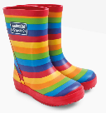
- FOREST SCHOOL – your child will have their first session on Thursday/Friday this coming week (17th/18th Sept) and will need to have a pair of wellies at school all week. If you require them back for the weekend, please remind your child to collect them on Friday but bring them back the following Monday! The wellies can be safely stored at school if you do not require them at home.
- Children should bring their own, named, re-fillable water bottle, every day.
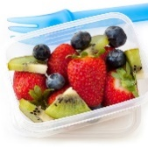
- Children can bring a healthy snack for break times – please note that these must be NUT FREE as we have children with serious allergies.
- Snack time is at 10.35-10.50am during morning playtime.
- We have school fruit for afternoon playtime, 2.35-2.50pm.
- P.E – Wednesday mornings. Although we are not currently changing for P.E sessions, please make sure your child has their kit at school.
- If your child has shoes with laces, please help them to learn how to tie them themselves and fasten their own coats.
- We are currently NOT setting any homework, but please continue to read daily with your child and practise reading and writing their name and numbers to at least 20.
- Please make sure all clothing and shoes are NAMED, especially jumpers!
Many thanks for your support, especially during these unusual times.
The Year 1 Team

