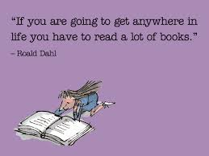
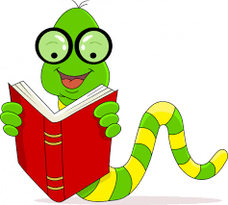
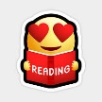
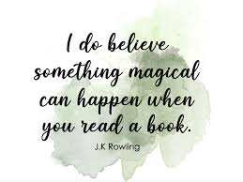
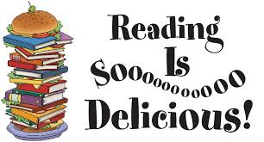
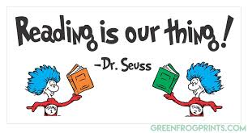
Reading Challenges March 2021
How many of these challenges can you complete in March?
5-10 challenges: Well done. You are a reader.
10-15: Great. You must be a book lover.
16-20: Fantastic! You are a book worm. You’ll go far.

Read under the covers | Read in your pyjamas | Read a book that was written before you were born | Read a book which is written in the first person
Read a magazine/comic | Read to an animal or a teddy/toy | Read outside | Whisper read
Read a true story | Read some news www.bbc.co.uk/newsround | Read a poem  childrens.poetryarchive.org | Read a book with pictures
Read a book that was published in 2020-21 | Read a book with a one-word title | Read in different ways (excitedly, nervously, quietly, sadly) | Read a book that has a cover in your favourite colour
Read a book that starts with the same letter as your name | Read a book with no pictures | Read a book with a number in the title | Ask someone to tell you about their favourite book

