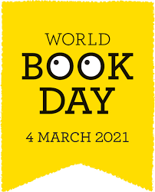
Competition Time

This competition is for all pupils in school and at home. Pass your entries to your class teacher by Friday 12th March. There will be prizes!
Which story character would you most like to meet and why?
Draw the character in the box and write your reason/s underneath it (a parent/carer can write for the youngest pupils). Remember to write your name and class on here too.

